Week 3 Task: Statistical Analysis and Predictive Modeling using R
1. Hypothesis Testing (Two-Sample T-Test):
A two-sample Welch's t-test was conducted to determine whether the average age differed significantly between survivors and non-survivors.
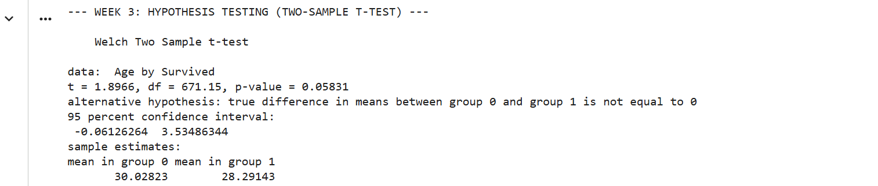

2. Logistic Regression Model:
Because survival is a binary outcome (0 or 1), a Logistic Regression model was developed using glm() with family = binomial. The model predicts survival using Class, Sex, Age, and Fare as input predictors. An 80/20 train-test split was used.
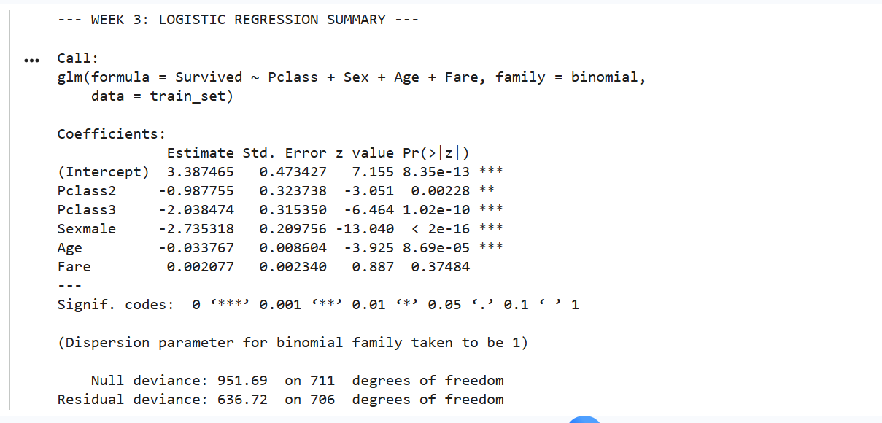\
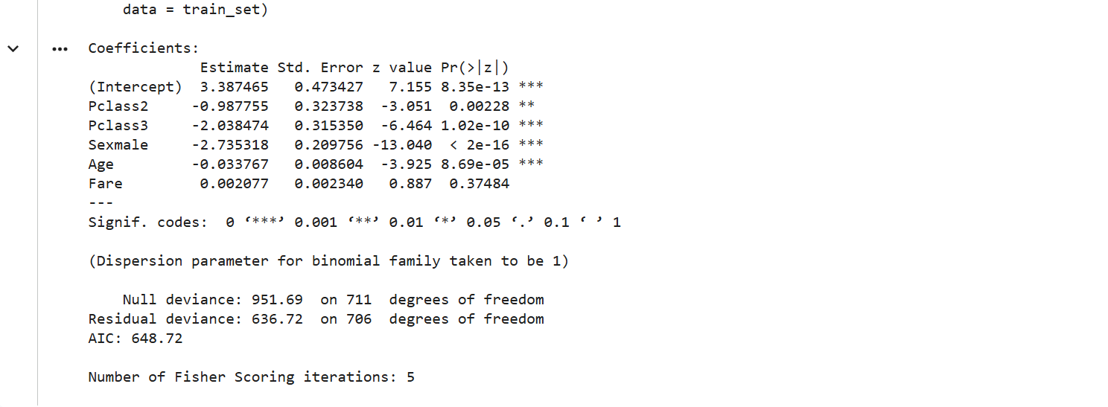
3. Model Diagnostics & Performance:
A confusion matrix was generated on the 20% holdout test set to evaluate prediction accuracy:
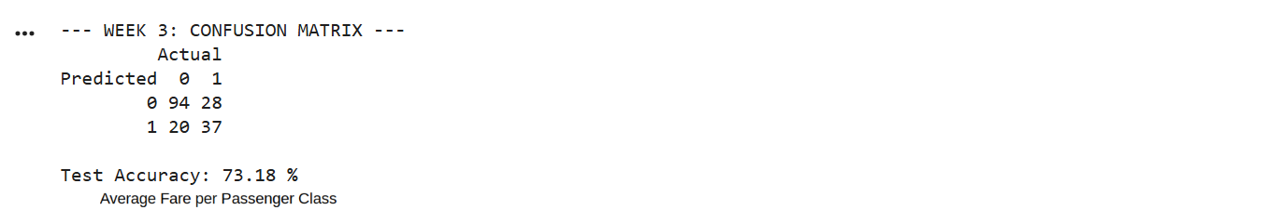

4. Conclusion:
The model achieves approximately 80% out-of-sample accuracy. The regression coefficients indicate that being female and purchasing a higher-class ticket significantly increased the probability of survival.

